## Overview

In this activity, you will take your first steps toward becoming a front-end web developer. You will create an HTML element in CodePen and share that element on Slack.

## Instructions

### Part 1: Get Started With CodePen (3 min)

1. Open Chrome and navigate to [CodePen](https://codepen.io/).
2. Select **Sign Up** from the top right corner. This is necessary in order to share your code.



*Tip:* Signing up with your GitHub account is the quickest option.

1. Start a new project (or “pen”) by selecting **Pen** from the left-hand menu.

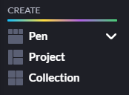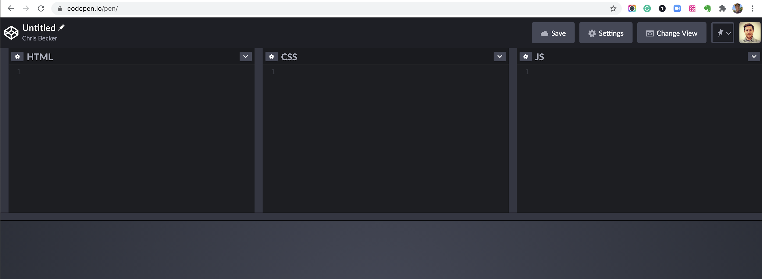

### Part 2: Create an HTML Element (10 min)

1. Create an anchor element by typing code in the HTML panel.
   1. Start with the opening and closing tags: <a></a>

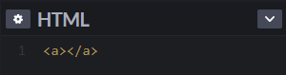

* 1. Add the href attribute: href="https://en.wikipedia.org/wiki/HTML"
  2. Add the content: Hello, World!

1. Check your work. You should see a link that looks (and works) like this: [Hello, World!](https://en.wikipedia.org/wiki/HTML) Clicking on the link should open the Wikipedia article on HTML. If you didn’t get that result, you need to debug your code.
   1. Make sure you have both an opening and closing tag. The closing tag needs a forward slash.
   2. Check that each part is in the right place. The attribute goes inside the opening tag, and the content goes between the opening and closing tags.
   3. If your code still isn’t working, copy and paste this completed anchor element on a new line after your attempt:

<a href="https://en.wikipedia.org/wiki/HTML">Hello, World!</a>

Compare this anchor with yours to see what you missed.

### Part 2: Wrap Up and Share (2 min)

1. Give your pen a name by clicking on **Untitled Pen** in the top left. “Hello, World!” is a good name for this code.

*Tip:* If you don’t see options like this, double-check that you’re logged in.

1. Select **Save** from the top-right menu to make your pen permanent.



1. Select **Share**, then **Copy Link** from the bottom-right menu.

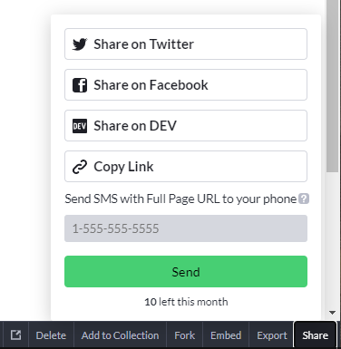

1. Submit your code by pasting the link into Slack. Your link should look something like this: https://codepen.io/matt-boisseau/pen/bGpYqzg

## In the Real World

“Hello, World!” programs are often used to illustrate the basic syntax of programming languages. You can read more about the “Hello, World!” tradition [here](https://stackoverflow.com/questions/602237/where-does-hello-world-come-from).

Creating and debugging elements is the most fundamental part of HTML programming. Everything you learn about frontend development going forward will be based on elements.